Making your own MP3 Voice Recording: Getting Started

You can make an audio recording on your computer with only a few clicks. Here’s how:

What you will need:
A microphone, either internal or external.
A computer.
Either Audacity (Free), or other personal recording software

Using Audacity- (if you have Apple Garage Band, scroll down):

Audacity, an easy-to-use, amateur recording and editing program, is available completely free with no strings or special offers attached, thanks to open source software developers.

System Requirements:

For Mac Users:
Audacity 1.2 requires Mac OS X 10.1 or later.
Audacity 1.0 requires Mac OS 9.0 or later.
Audacity runs best with at least 64 MB RAM and a 300 MHz processor

For Windows Users:
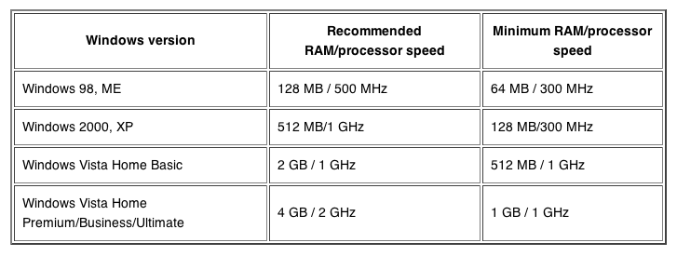

1. Go to http://audacity.sourceforge.net/

2. 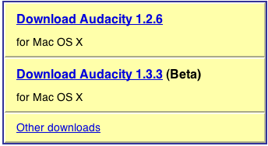
Click “Download Audacity 1.2.6”

3. For Mac OSX Users, select the link in the first bullet, “Audacity 1.2.6”
For Mac OS9 Users, select the link in the third bullet, “Audacity 1.0.0”
For Windows Users, click the “Windows” button along the left side of the page, then select “Audacity 1.2.6 Installer”

4. Mac Users: Audacity will save as a DMG file. Open the file and drag the folder into programs to install Audacity to your computer.
Windows Users: Install Audacity and open the program
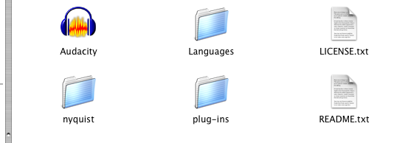

5. Open the Audacity folder and double click on the Audacity 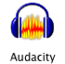program.

6. Make sure your recording device is plugged in. (If it is USB, make sure it is plugged securely into the USB port. If you have an internal recording device, you may want to try using an external device first if there is one available. Internal devices are suitable, but often pick up more ambient noise.)

7. To make sure your recording device is connected properly, open System Preferences and click “Sound.” Click the “Input” heading and make sure your external microphone or internal microphone is selected.

8.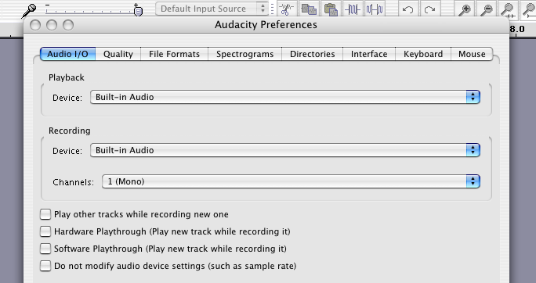
To ensure that Audacity is using the correct devices, click “Audacity” along the top bar, then select “Preferences.” Under the first subheading, select the device you want as output (you may want to use headphones to make sure your computer’s speakers are not picked up by the microphone- you can also turn the sound off on the computer’s speakers instead) and make sure your microphone device is set to input.

9. You are now ready to begin recording. To record, press the button along the top toolbar and begin. It is best to provide a bit of lead, as you can delete and edit space after the audio has finished recording. You may want to test the quality of your recording, including ambient sounds and how close you should speak into the microphone, by playing a small bit back to yourself (click stop during the recording, click on the beginning of the audio track that appears as you record, and press the space bar to play back what you have recorded so far).

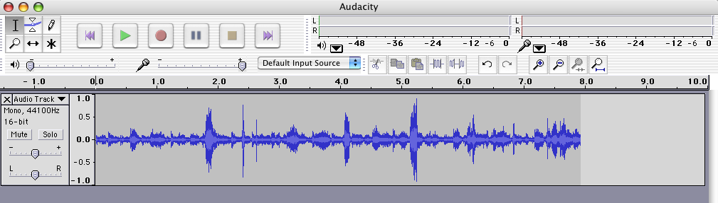

10. Once you have finished recording your audio, you can then listen to the audio and select portions you would like to remove. A little too much pause? Highlight and remove some of the space. Need to delete dead time at the beginning? Again, highlight and remove. To delete a track and start again, press the ex in the top left corner of the track window, next to the title “Audio Track.”

11. Once you have your finished product, click “File,” “Export as MP3,” type a file name for your product, yourname-spokenonly.mp3. Now you are ready to send in your own recording!

Burning Your MP3 to a CD using iTunes:

Downloading iTunes:
If iTunes is not already installed onto your computer, it is available for free at http://www.apple.com/itunes/.

Click “Free Download” in the middle of the screen. Enter your email address and check or uncheck the special offers above.

If you have Mac OSX, click the download button below your email address.

If you have a Windows-based system, click “Get iTunes for Windows” at the bottom of the screen, select your operating system, and then click the download button below your email address.

After iTunes has finished downloading, open the file to install to your PC or the programs folder of your Mac.

Burning to a CD:
1. Insert a writeable CD (CD+R, CD-R, CD-RW) into your CD drive.
2. Open iTunes
3. In iTunes, click “File,” then “Import”, then find and double click your saved .mp3 audio file
4. In the search tool in the top right corner of your iTunes, type in the name you saved your .mp3 file under and wait for the file to appear.
5. When the file appears, highlight it by clicking on it once, then click “File,” “New Playlist from Selection.” Your file should now appear in its own playlist along the left hand side, the Library
6. Now click the “Burn Disc” button in the bottom right hand corner. Your burn should begin.**

**If in the rare case you receive an error saying that the file you wish to burn is too large, follow these directions to reduce the size of your file:
1. In iTunes, highlight the audio file you created and then click “iTunes,” “Preferences” for Macs, or “File,” “Preferences” for PCs.
2. In your preferences, click on the “Advanced” tab, with the cog icon.
3. Click on “Import”
4. In the “Import Using” title, click the drop down menu and select “MP3 Encoder”
5. Next to “Setting” click the drop down menu and select “Good Quality (128 kbps)”
6. Now close the advanced settings and return to your highlighted song
7. With the song still highlighted, click on “Advanced” at the top, then “Convert Selection to MP3”
8. You will now see two copies of your audio file. With the same original file highlighted, delete that highlighted audio, leaving the newly created, smaller copy untouched.
9. Now follow the burn procedures previously mentioned. If you still experience an error, this means that your audio file is too large, but the one track should not cause such an event. Your file may need slight shortening, or you may try converting the audio to an even lower quality MP3.

Now that you have your MP3 on a CD, send it to the Missouri Review along with the Entry Form available at www.missourireview.com.

